SpaCeParti

Coastal Fishery, Biodiversity, Spatial Use and Climate Change: A Participative Approach to navigate the Western Baltic Sea into a Sustainable Future

Coastal fisheries in the Western Baltic Sea are under great pressure, with unforeseeable consequences for the economic development of the associated coastal communities. Anthropogenic influences such as overfishing of cod and herring, eutrophication of the Baltic Sea as well as climate change are major contributors. In addition, fisheries increasingly suffer from spatial conflicts for instance with necessary nature reserves to preserve biodiversity and wind farms to mitigate climate change. On land, growing tourism is taking up more and more space on the coasts, which can lead to displacement of commercial fishers by recreational fisherboats.
The various conflicts between civil society and other interest groups need to be resolved in a sustainable way. Therefore the project SpaCeParti pursues the following goals:

Goals
Development of scientific and policy action knowledge to steer the fisheries of the Western Baltic Sea towards a sustainable future, while protecting biodiversity, and take into account tourism and offshore energy production.
1. Options to prevent the economic collapse of the Western Baltic fisheries and the resulting socio-cultural consequences.
2. Ideas for the transformation of fisheries from an endangered economic entity to a sustainable socio-ecological economic form.
3. Development of sustainable solutions to the multiple conflicts between user and interest groups and civil society.

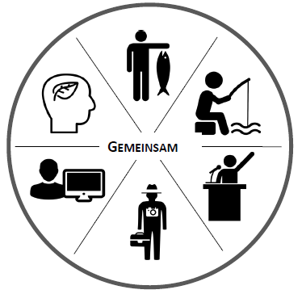
IMPLEMENTATION IN LIVING LABS
In Living Labs, science and society meet and jointly seek solutions for sustainable development of Baltic Sea Fisheries.
Living Labs are spatially limited, e.g. a community on the coast where researchers and fishermen exchange knowledge and ideas.
This transdisciplinary cooperation is the key to sustainable developments because they are jointly conceived, developed, tested and reflected upon by various stakeholders in society.

CONTRIBUTION TO CLOSING CURRENT KNOWLEDGE GAPS
The practical relevance in Living Labs is linked to 5 research work packages. In this way, current knowledge is made practically usable, while new knowledge is generated and supplemented through international cooperation.
The broad range of topics includes understanding the functioning of the Western Baltic Sea ecosystem and its biodiversity, especially with regard to the fish species cod and herring. In socio-economic analyses, political processes and pressures on fisheries are examined. Future scenarios will be created for both the development of the fish population and the development of fisheries, which provide a basis for better fisheries management.
Finally an holistic assessment of the processes concerning the fisheries of the Western Baltic Sea will be carried out in order to develop action proposals for policy, in which options for a sustainable future of fisheries will be identified.
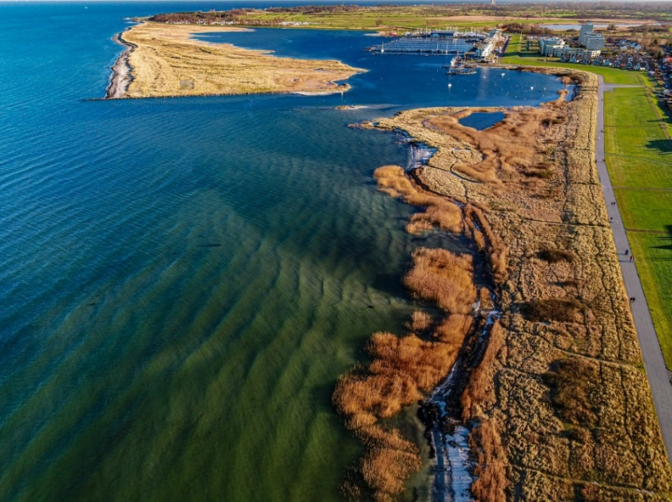

©Etter & Karstens, CeOS, University of Kiel

__________________________________________________________________________________________________________________________
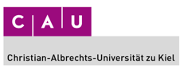
Consortium:
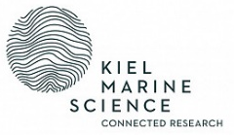
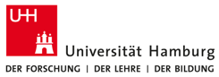
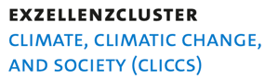
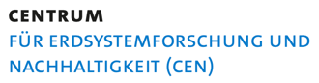

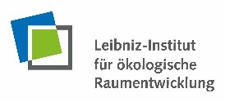

_________________________________________________________________________________________________________________________
Projektlaufzeit: 1.12.2021-30.11.2024

